David Browne, Director Automotive Design, Coventry University 03 Jul 2007

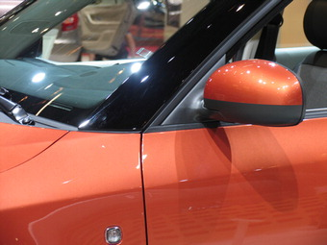
Here, the beltline is defined by the color break between orange body and the black elements: it runs under the door mirror and around the windscreen

Beltline
The line directly underneath the side windows of the car, the junction of the upper greenhouse and the lower bodyside or shoulder.
Emphasis may be given by the addition of a bright strip or by a change in body section which will produce a more subtle running highlight
The position and inclination of the beltline not only affects the appearance and proportion of a car, but also its character and stance. A car with a low beltline - and therefore tall greenhouse - may look 'delicate', elegant or modern. A car with a high beltline, and correspondingly shallow greenhouse, will tend to look tough and mean.
A rising beltline provides the long-fashionable 'wedge' appearance and imparts a dynamic sense of purpose and direction.
UK English: Waistline
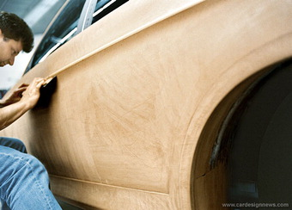
Working on the body section of a clay model

Body Section
A vertical slice through a car body side which is then viewed at 90 degrees to help understand or appreciate the form. Tape lines applied to the surface show a section nicely, the trailing edge of an open front door describes it perfectly, but only at that point - body sections are rarely constant.
A simple glance at typical body sections will reveal that most have convex main surfaces, although creases and feature lines may introduce local negative contrasts. It was the introduction of unexpected 'negativity' on BMW's principal surfaces that caused such a reaction to Chris Bangle's 'flame surfacing'.
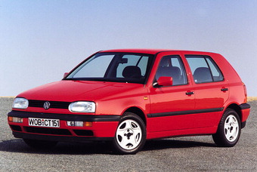
A typical body wide line as shown here by the black body side protector

Body Wide Line
The lateral line at which the maximum width of a car can be measured (excepting door mirrors).
It may be created by a crease or any of the main body section lines, but for practical purposes it is usually designed to be an applied body side protector moulding or rubbing strip.
The current fashion is to avoid added body side protectors, with the body wide line defined by a more subtle body crease.
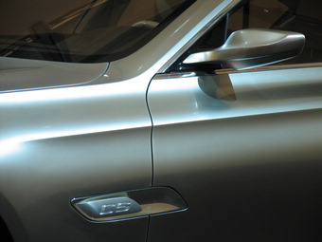
A bone line is a linear 'peak' in a car's bodyside
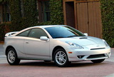
Lexus LF-A - Design Review
Bone Line
(See also swage line, feature line, crease, character line)
There can be a fine line between some of these terms, and this has led to a certain conversational 'interchangeability' of terminology, and to some loss of their true meanings and origins. Though not structural per se, all have an important primary function in reinforcing body panel stiffness and reducing vibration. They will, however, be part of the visual structure of a car.
Their principal purpose is to variously create definition, add emphasis, visual interest, design organization, and to direct - or even deceive - the viewer's eye.
A bone line is a hard, positive only, linear 'peak' in a car's bodyside, more prominent than a crease line.
To contrast with the often-used 'taut skin over muscle and sinew' metaphor, this implies sheet metal, similarly stretched, but over something more structural (see haunch).
An interesting, or unique, bone line can also be a character line eg. 2000 Toyota Celica, Mercedes CLS.
Bonnet
UK English term for hood
Bulkhead
UK English term for firewall
1987 Chrysler Portofino concept (above). 1998 Dodge Intrepid ESX II (below left). 1993 Dodge Intrepid (below right)
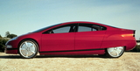
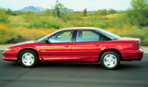

Cab Forward
Chrysler's marketing department is credited with coining this one to describe their 1987 'Portofino' Concept Car, though some say it was Ford design Vice President, Jack Telnac. Railway enthusiasts however, will recognise the term from Southern Pacific's Cab Forward locomotives of the early 1900s.
The overwhelmingly positive reception for the Portofino, plus the instincts of a then fairly desperate Chrysler management team, led to the production of a stunning family of cab forward products: the 1993 Dodge Intrepid and the 1994 Chrysler LH and New Yorker which made even the once trend-setting, but admittedly ageing, Ford Taurus (Scorpio) look pretty dull. These cars also heralded the resurgence of Chrysler as an automotive design force.
The benefit to the overall package was space: by moving the screen, driver and passenger forward, space was liberated for the rear compartment, and this was further enhanced by moving the (non-driven) rear wheels, and therefore wheel arch intrusion, backwards. One way and another, it was a pretty innovative package & style combination - particularly in the context of full-sized American cars.
At the other end of a theoretical cab position scale, you would have to put the hugely 'cab rearward' slingshot Mercedes-Benz SLR McLaren.
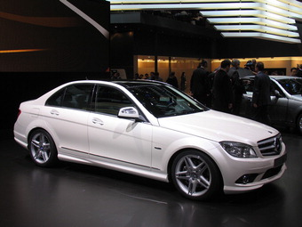
Mercedes-Benz C-Class (above), Citroen Pluriel (below left), Smart RoadsterCoupe (below right)
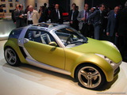

Cant Rail
The structural member which usually sits squarely on top of the B-pillar forming the top edge of the door frame aperture, and which may run (visually) seamlessly into the A and C pillars, an arrangement most clearly defined by glass-roofed versions of cars such as the Mercedes C-Class (illus).
Side curtain airbags are located on the inside of cantrails.
The Citroen Pluriel and Smart Roadster have removable Cant Rails.
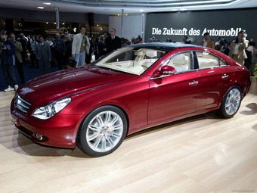
A character line gives both definition and personality to a car
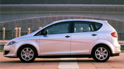
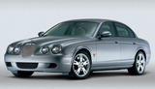

Character Line
An important feature line or crease which may be sculpted, or more pleasingly, created by the meeting of 2 planes on a car's surface, and which gives or adds both definition and 'personality' to the form.
A character line is more fundamental to, and therefore more important to a design than a feature line or a crease, and in the best examples may be sufficiently unique to represent that car when abstracted eg SEAT Altea. The slightly 'banana-ed' sculptural character line that echoes the beltline and sweeps the flanks of the Mercedes CLS is also present on the A-Class, B-Class, R-Class and, in indented form, the commercial Viano, so is also a major expression of current Mercedes form language.
By contrast, the more 'scribed' character line on the bodyside of the Jaguar S-Type, intended to recall the 1960's 3.4 and 3.8S, is unique to that model, and doesn't appear on any other Jaguar.
See: Surface language
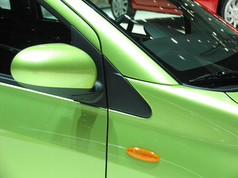
Front cheater (above) and rear cheater with incorporated door handle (below right)
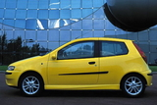
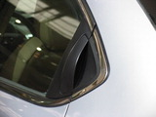
Cheater Panel
The small triangular, usually matt black-painted, surface at the base of the A-Pillar. It generally forms the leading edge of the side glass graphic - or DLO - on, or just ahead of, the front door, and which may usefully disguise sculptural 'uncertainties' in this awkward, but key, conjunction of 3 planes. For such a small item, its contribution is surprisingly important, as can be seen when it is not there. (illus: Fiat Punto)
Functionally, if in the door, it happily provides a natural platform for external rear-view mirrors and a useful channel for the front glass drop.
Rear Cheater
Again, a small, usually matt black-painted, triangular panel at the base of the trailing edge of the rear side window or in the rear quarter panel. In the former, its function will be to create a shorter door glass, to provide a vertical channel, and to enable the window to be lowered without obstruction from the door closing and locking mechanisms.
Functional considerations aside, front and rear, designers will have attempted to create the illusion of a longer and more elegant DLO.
Also known as the 'Flag' in USA
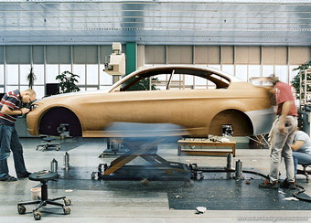
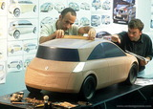
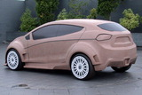
Clay
Automotive Styling Clay is a dull brown, grainless, wax-based material, originally of US origin, used as a top, finishing surface for scale and full-size exterior and interior models. Although temperature-sensitive, unlike water-based ceramic clay, it doesn't dry out, and cannot be fired.
It is preheated in 1 kg billets in ovens to a working temperature of around 60 degrees C, at which it is very malleable, and is applied as a 25 mm or so skin over a structure called a 'buck' or 'armature'. When it cools to room temperature, it is then sculpted using a variety of hand tools or computer-controlled 3 and 5-axis milling machines.
The particular advantage of clay is that it can as easily be added to as subtracted from, and the finished product is, literally, seamless.
Dressed Clays
As clay is such a dull, lifeless material, clay models need a bit of help to be readable and properly understandable by the non-designers who may make choices and decisions based on what they're looking at - and what they think they see.
The simplest form of 'dressed' clay - whether small scale or full-size - is one in which the glass areas are 'blacked out'. This can be achieved quickly and easily using black masking tape, black paint, or more uniformly using Di-Noc.
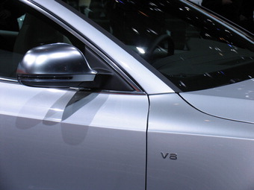
The Audi A5 (above) has a pronounced crease line at the shoulder.
Toyota bbka
Crease Line
A crease is the pressed or folded line created by the meeting of two different planes or surfaces.
Unlike feature lines, a crease is integral to a design, and cannot simply be applied to a surface, but is commonly the means of defining major surfaces and elevations. Ford's 'New Edge' design used creases (mainly) to graphically define the boundaries - or edges - of the various surfaces on the Ka, Cougar etc.
A crease may be positive or negative, but has more inherent 'integrity' than a feature line. However, a particularily strong or interesting crease in an otherwise simple surface might take on the importance of a character line.
Two very adjacent creases may 'conspire' to create a feature line: Giugiaro's 1974 Mk 1 Golf (illus) had relatively flat body sections with crisp, straight, and uniform - almost folded - feature lines, and was referred to by Ford's Design Director, Uwe Bahnsen, as coming from the 'Origami' school of styling.

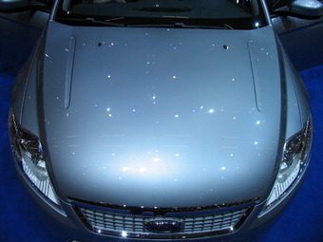
Hood surfaces always exhibit considerable crown

Crown
Crown in a panel is compound curvature - usually convex: in one plane it would simply be 'curvature'. To the engineer, crown provides inherent stiffness; to the designer it enables the control of highlights and lightlines.
The appearance of flatness can be achieved and accurately controlled by the use of gentle crown, but true flatness can't.
A simple way of 'measuring' crown is to compare it with an offered-up straight-edge. There is always considerably more crown - in any direction - on automotive surfaces than seems apparent, likely, or even possible.
Glass is not considered to have crown. Glass surfaces, particularly windscreens, are to all intents and purposes, single curvature: the principal curvature - in plan for front and rear screens, end elevation for side glass - dominates any slight, but necessary curvature in the opposing planes.
DLO framed with a bright strip [above]. The Mini [below] continues the DLO around the car
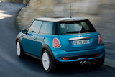
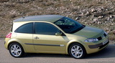

DLO
The expression derives from 'Day Light Opening' and is used to describe the graphic shape of a car's side glass. The DLO is the strongest and most important graphic element of a car's design, as it provides the opportunity to create a major contrasting surface which can be employed to flatter or accentuate a form.
Where there's graphic continuity, it may also include the front and/or rear screens. This notion has really only been convincingly achievable since the advent of flush glazing and bonded front and rear screens which additionally enabled non-opening pillars to be glazed over (illus. Mini)
The desired effects work best with lighter colours which contrast strongly with relatively dark tinted glass, blacked-out pillars, cheater panels and internal window 'masking'. (This is the reason most cars are designed in silver) To add further emphasis - or to add some in the case of dark-colored cars - the DLO may be 'outlined' with a bright strip.
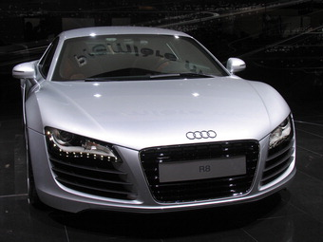
Audi R8 features LEDs in headlamps for more agressive DRG

Down the Road Graphics (DRG)
The design features and characteristics of the front end or 'face' of a car which enable the marque to be immediately identified from a distance.
By joining up the dots, Audi's initially controversial new face banished the anonymity of the dull letterbox grille, and made them identifiable a mile away.
Reduced ground clearance, fatter tyres and extended wheelarches are readily spotted performance signifiers which introduce the similarly distance-related notion of 'down-the-road dynamic'.
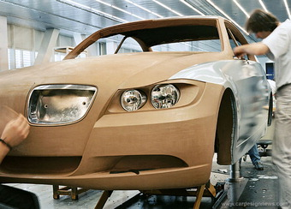
Di-Noc
A thin, pre-painted stretchable plastic film made by 3M that is applied rather like a transfer by sliding it into place off its wetted backing paper.
In a normal clay model, door and other shut lines, wheels and other areas of contrast will be added, leaving the bare clay to represent the painted surfaces. This provides effective 3-D graphic contrast, and a representation, which those with a trained eye find rather pleasing.
However, the subtleties and finer nuances of the design may still effectively be 'camouflaged' by the non-reflective clay, so the next step will be to Di-Noc or paint - usually in silver - the remaining surfaces. The advantage Di-Noc has over paint, is that it can be simply peeled off to facilitate design changes - paint has to be scraped off, damaging even those surfaces which don't require change.
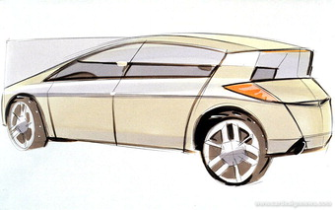
Too many feature lines can spoil and interrupt a design [below]
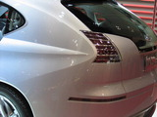
Hyundai neoskb
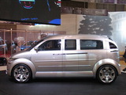
Suzuki pxc
Feature Line
A simple line in a car's body surface. The best feature lines will be sympathetic to the design of a car, but some may simply have been introduced to relieve otherwise dull or large areas of 'plain' sheet metal.
They can also be used to accentuate the form, and to link, tie-in, co-ordinate or visually organise the loose array of items such as door handles, vents, rear number plate recess, front and rear lenses etc which appear on all cars.
Any and all body panels may have feature lines - some have been known to have too many.
See also crease line

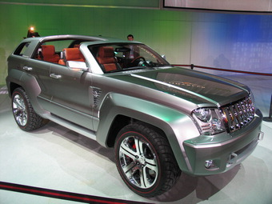
Fenders have evolved from being separate (below L) to more integrated
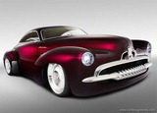
Fender
Fenders are those local panels which are legally required to wrap or cover road wheels, protecting the bodywork - sometimes the occupants - and other road users from spray, dirt, stones and anything else thrown up by the revolving tyres.
In their early, simplest form, they closely followed the shape of the wheel, like bicycle mudguards - hence the name 'cycle wings'. The front ones particularly were quite separate from the body and often turned with the wheels. Today, identifiable front fenders live on in all body configurations, but rear fenders only in three-box saloons: in hatchbacks, the panel which accommodates the rear wheel is referred to as the rear quarter panel.
Some vehicles, such as Jeep (pictured right), still retain identifiable fenders but in most cars they have become integrated in the overall body. There is a fashion for fenders to become more prominent again, in a bid to suggest power or for a better stance (illus. Chevrolet Volt).
Cheap, light and easily-replaceable plastic front fenders are 'discretely' used on a number of cars - the Mercedes A-Class for example. Renault has used plastic front fenders on many models for years.
UK English: Wing
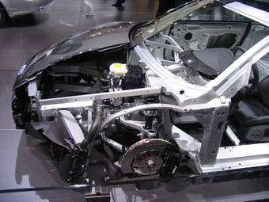

Firewall
The structural panel which separates the engine compartment from the passenger compartment. Principle functions are sound and heat insulation, but the firewall may also support an array of items like battery, screen wash bottle etc.
Sports cars and some sedans have rear firewalls, though in this day and age of versatility and flexibility, many sedans have folding rear seat backs engineered to function as firewalls when upright and able to resist intrusion by the contents of the trunk. Others have a centre armrest which doubles as a fold down 'ski hatch'.
UK English: Bulkhead
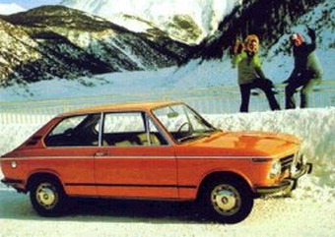
The BMW 2002 had a particularly light, airy greenhouse

Greenhouse [or Glasshouse]
The upper, glazed, part of the passenger compartment which 'sits' on the bodywork. This conjunction is referred to as the beltline or waistline.
The expression came into common use in the early 1960s as slimmer pillars, larger glass areas, and side windows with separate frames which were not an integral part of the door pressing (and therefore not body colour) gave rise to a more completely glazed appearance.
As front and rear screen angles have become ever 'faster', and tumblehome more pronounced, conspiring to increase solar gain, this piece of terminology is finally coming into its own.
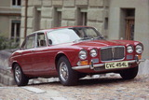
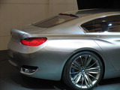

Haunch
Where the shoulder of the car gently swells out to accentuate the muscularity of the rear wheel. Haunch is the name given to the sculpting of the fender panel above the rear wheelarches, which alludes to skin tightly stretched over the well-toned muscles and sinews of the athlete, and therefore implies substantial power and performance.
It obviously makes most sense in rear wheel drive cars, and haunches have been an essential ingredient of the generic rear-wheel drive coupe form since before the term was coined. Haunches are most often associated with Jaguar, who have used this device as a key part of their form language on many models since the 1950's.
In performance-orientated versions of standard cars, more heavily sculpted wings with prominent haunches and extended wheelarch eyebrows will also accommodate the inevitable wider-profile wheels and tires, which in turn adds a more purposeful stance - it all stacks up nicely!
Haunches are often referred to as 'rear haunches' which implies that there may be front haunches too: this is not the case - haunches are always over the rear wheels.
Also referred to as 'Hip'
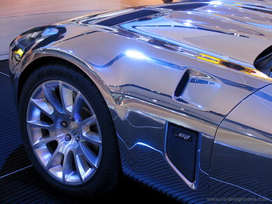
Highlight
These exist on the surfaces of all shiny objects, and are key to describing and understanding form.
A highlight is a visible concentration of light which 'flares' off a lightline at a point which is dependent on the position of, and will move with, the viewer. As with lightlines, particularly sharp creases etc will create crisp, tight highlights, and gentler ones will generate correspondingly bigger but softer highlights.
Lightlines are effectively 'paths' of reflected light which 'run' along a surface and make it possible to understand its sculptural form without reference to its outline shape (though, of course, the additional information provided by outlines helps build the complete picture)
A car is not, of course, a purely static object, and as the car (or the observer) moves, both lightlines and highlights will travel along and around its surfaces. Organizing this flow around a complex 3-D form so that it works from any and all angles and views is hugely challenging, and requires great sculptural feel and experience.
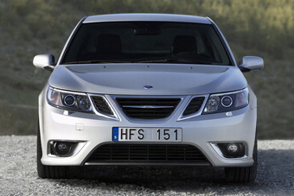
Clamshell hoods used by Saab, Land Rover and Hummer
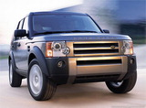
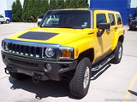
Design Essay: Interior Texture Trends - Europe vs USA
Hood
The exterior body panel which covers the engine compartment of front-engined cars (they're called 'engine covers' on rear-engined cars) and which can usually be lifted or opened to provide access to the engine (the Audi A2's is fixed). The trailing edge is called the 'hood cowl line'.
Hood shut lines are usually on the top surface and flow neatly forwards from the inside edge of the A-pillar. Most Land Rovers and Saabs have signature 'clam shell' hoods which effectively incorporate the tops of the front fenders, moving the shut lines (and their associated flanges) to the body sides.
European legislation relating to pedestrian safety now requires an 81mm clearance between the hood and the immovable engine and suspension components beneath, for all European-market cars.
Some makers, such as Jaguar, have avoided this height penalty by developing a 'pyrotechnic deployable' hood for the new XK8 - an expensive solution which preserves the low front fender line expected of a sportscar.
UK English: Bonnet

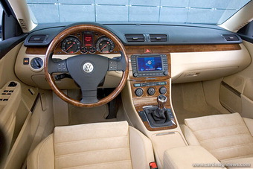
Instrument Panel (IP)
The Instrument Panel (or IP) is a hugely important, multi-functional 'platform' which contains information displays relating to a car's performance, well-being and geographical location; major and minor controls, switches etc, heating and ventilation outlets, storage access and of course, the obligatory cup-holder. It also conceals a number of functions - the passenger airbag, the air conditioning/ ventilation/screen demisting systems and their associated trunking, an important structural cross-member etc - all which are best left unseen.
To reduce the confusion created by the multiplicity of switches and controls several secondary functions such as radio CD/MP3 controls are accommodated in the centre console, or have been moved to stalks or the steering wheel, while electric window and seat adjustment switches can often be found located on door or armrests - still easily reachable, but out of direct line of sight.
Otherwise known as 'crashpad' and 'dashboard'. The term 'dashboard' originates from the board upon which stones were dashed up from the road and thus originally was to protect occupants from this on Veteran cars (and horse-drawn carriages prior to this).
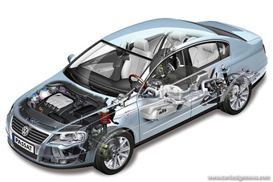

Platform
It is not unreasonable to think of a platform as a latter-day chassis - a basic structural and mechanical 'architecture' subsequently clad in the visible sheet metal (etc) of the bodywork. It's the invisibility of the elements of the platform - typically powertrains, suspensions and structural pressings such as floorpans and firewalls - which enable the widespread practise of platform sharing and the massive economies of scale to be achieved.
A commonality of around 60 percent is typical with platforms shared across brands (eg PSA Group), but as much as 90 precent can be achieved in examples of 'in-house' badge engineering.
Champions of platform sharing are the VW Group who have managed to spread their A4 platform across four brands, eight products and six different body configurations.
Where brand image is key and needs to be protected, module sharing of components within a platform (such as air conditioning systems, electrical components, safety items, etc) is an area where investment, development time and unit costs can be saved.
1971 Lamborghini Countach

Screen Angle
This is the angle the windshield of a car slopes back from the vertical, measured at its centerline. A 'faster', more acute angle traditionally signifies a sportier kind of car.
The limit, however, is physical rather than legislative: as the screen angle increases, so too does the likelihood of internal refractions, 67 degrees being the angle at which laminated glass effectively starts to become opaque. The Lamborghini Countach was pretty much on the limit for screen angle.
The glass areas are part of a car's sculptural form, and while a screen will be substantially flat in front of the driver's eyes, double curvature may be introduced at the sides where the screen wraps round to meet the tumblehome of the side glass.
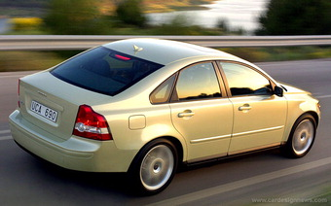
Volvo's broad yet softly radiussed shoulders have become a key part of their marque identity

Shoulder and Shoulderline
The shoulderline basically runs the length of a car's upper body side where it folds over to meet the side windows and its nature will reflect the essential character of the car.
The surface between the shoulderline and the beltline directly below the side windows is referred to, reasonably, as the shoulder: amusingly, it is therefore below the beltline. It shouldn't be confused with the similarily-positioned haunch.
Volvo's trademark shoulders have been developed into a marque identity characteristic, which emphasizes strength - and therefore safety - a long-held Volvo byword.
See also Beltline
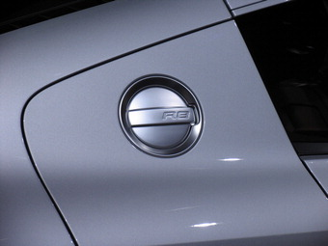
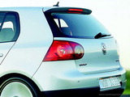
Shutline
A shut line - or 'cut line' - is the necessary clearance gap between two adjacent exterior body panels or interior trim panels, either of which may be openable. They may be identified individually as 'door shuts' or 'hood shuts' etc and their tightness and consistency are reliable indicators of build quality. Continuity of surface and feature lines, and alignment of adjacent panels is now taken for granted.
Designers seize every opportunity to incorporate shut lines which will help describe a car's form and reflect its character, and which will be consistent with its surface language.
VW has the most harmonious shutlines (illus. Golf IV five-door), and BMW the most 'meandering'.
BMW's new CS has a great 'stance' to it
Stance
'Stance' suggests both attitude, intent and ability, confers presence, and is equally identifiable whether a car is stationary or on the move. (The apparently-similar term 'poise' refers to a car's dynamic behavior). Stance is largely defined by the body-to-wheel and the overall vehicle-to-ground relationships which are important in all cars, but vital on those for which 'attitude' is critical.
Wheels that fill a car's wheelarches in depth as well as diameter will suggest a confident stability. Wheels and wheelarches pulled out from the body sides will imply performance and even aggression, as will minimal ground clearance. Conversely, generous ground clearance is both a physical and visual requirement of an 'off-roader' vehicle.
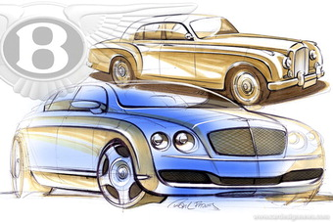
Surface Language
The basic form language of the car that defines the design.
Extremes of surface language would include terms such as soft, organic and flowing or else hard-edged, geometric and boxy. It also alludes to the complexity of the surfaces eg simple, plain or busy, fussy.
Surface Language also extends to the nature of the way that the various body surfaces meet and the details within the surfaces such as grilles, lamps and other graphic elements. The language would be described by adjectives such as formal, sporty, casual, hard-edged, etc.
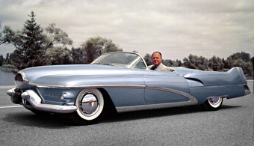
Chrome swage lines on Harley Earl's 1951 Le Sabre concept

Swage Line
Swaging is a technique in which cold metal is formed over a grooved tool or swage. In the early automotive context, the edge of one panel was swaged so that it could overlap its neighbor to create the impression of a continuous surface - usually running along the beltline or waistline. By the time production techniques made one-piece doors possible, the swage line had become a popular, elegant device (and a useful division in two-color paint schemes) often concealed by coachlined or chromed 'waist moldings' effectively becoming, in the process, a feature line.
Today, the term is often used generically - particularly by those with an engineering background - for any raised, continuous, pressed bodyside crease or feature lines.
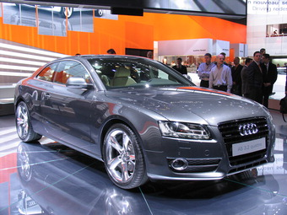
A car with more tumblehome suggests a faster, sportier car. The Lamborghini Countach had the most severe tumblehome of any production car.
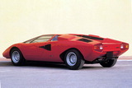
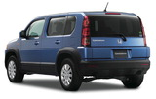

Tumblehome
Tumblehome is nautical terminology. It was introduced to automotive design with the advent of curved side glass and the need to describe the convex inward curvature of the side of a car above the belt line or waistline.
Unlike screen angles, the degree or amount of tumblehome is not measured. Oddly, while more recent cars tend to have a lot of tumblehome, this may now be reducing again in order to accommodate cant rail-mounted curtain airbags without further intrusion to lateral headswing.
The amount of tumblehome needs to be carefully balanced by the designer as part of the overall car package. Cars such as the Fiat Multipla or Honda Crossroad (illus. bottom right) are examples of cars with very liitle tumblehome, due to their emphasis on practicality and spaciousness.

Waistline
See Beltline
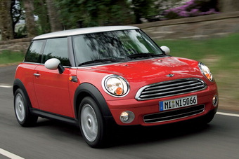
BMW's new Mini (above); Lamborghini Countach (below left); Mercedes-Benz 300SL (below right)
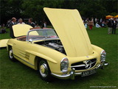
Wheel Arch
These are essentially circular apertures in the body sides which admit the road wheels, and importantly, frame them. At their simplest - and often most satisfying - wheel arches appear to have been surgically cut out of the body sides.
The relationship of wheel to wheel arch is critical, and designers attempt to make the former fill the latter as fully as possible.
Wheelarches - and the wheels - may be emphasized by pulling out the body sides locally or by the addition of wheel arch extensions or 'eyebrows'. Usually textured matt-black plastic, these offer the added bonus of reducing the depth of painted sheet metal between the wheel arch and the top of the wing (illus. new Mini). Clever detailing on the sheet metal may be used to achieve the same result. Larger diameter wheels are an important visual ingredient of a car's exterior, but there is a price to pay: inner wheel arch intrusion will be greater and, in the worst cases, may force offset pedals or the complete driving position.
Although wheelarches tend to conform to either of a few types, there have been some 'trademark' excursions: the aerodynamic 'blisters' on the 1954 Mercedes 300SL; Gandini's distinctive rear arches on the original Lamborghini Countach and the slashed affairs on the Chris Bangle's 1993 Coupe Fiat.
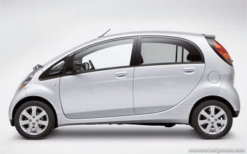
Extremes of wheelbase proportions: Mitsubishi i (above), Bentley and Audi Quattro Sport (below right)
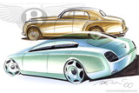
Wheelbase
This is the distance between the front and rear wheel centers, and a critical dimension in the quest for internal space efficiency and optimized accommodation.
Successive models in all manufacturers' ranges tend to be incrementally bigger than their predecessors, but the biggest dimensional gain is invariably to the wheelbase. Overhangs consequently have been quietly shrinking.
The wheelbase is also a critical dimension visually, contributing greatly to the balance and proportion of a car. There are plenty of examples of cars whose appearance has been compromised by inheriting cost-saving hand-me-down platforms from unsuitable relations.
There have traditionally been long wheelbase (LWB) versions of prestigious sedans, the extra length all going into the rear compartment - space, after all, being a luxury. Conversely, lighter and nimbler short wheelbase (SWB) versions of some cars have been specially prepared and homologated for rally use, most famously perhaps, the all-conquering Audi 'Quattro Sport' which took over from the regular Quattro in the mid 80s.
Wing
See Fender

