Diagram Tipe-tipe Riset Berdasarkan Perspektif dan Metodologinya

Types of Research

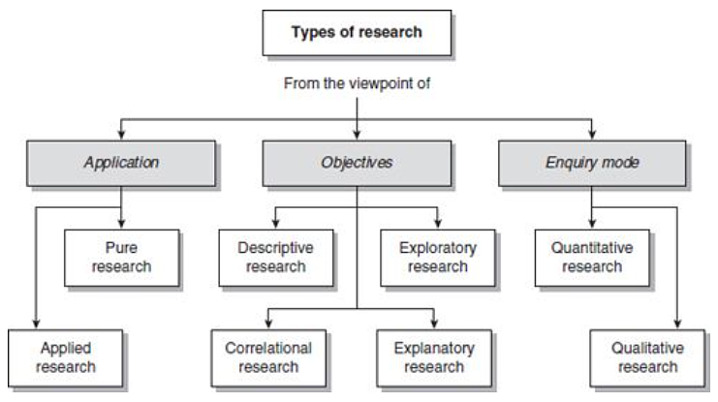

The Apllication Of Research (Pengaplikasian Riset)
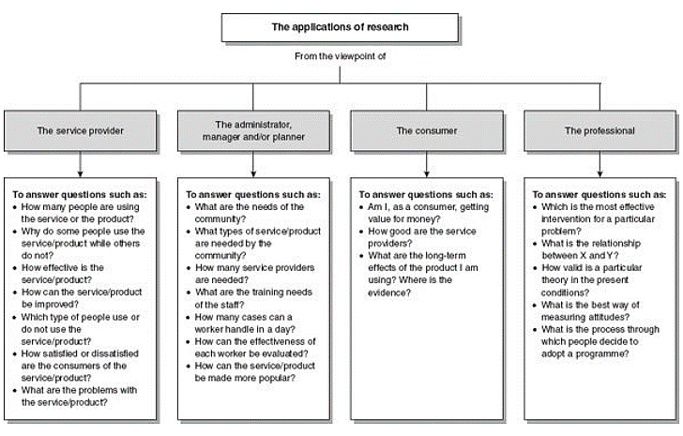

Types of research studies from the perspective of objectives
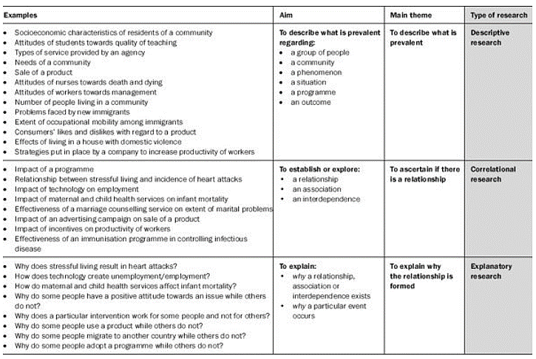

Types of research from the perspective of (data)enquery mode
The Differences: Quantitative vs. Qualitatif
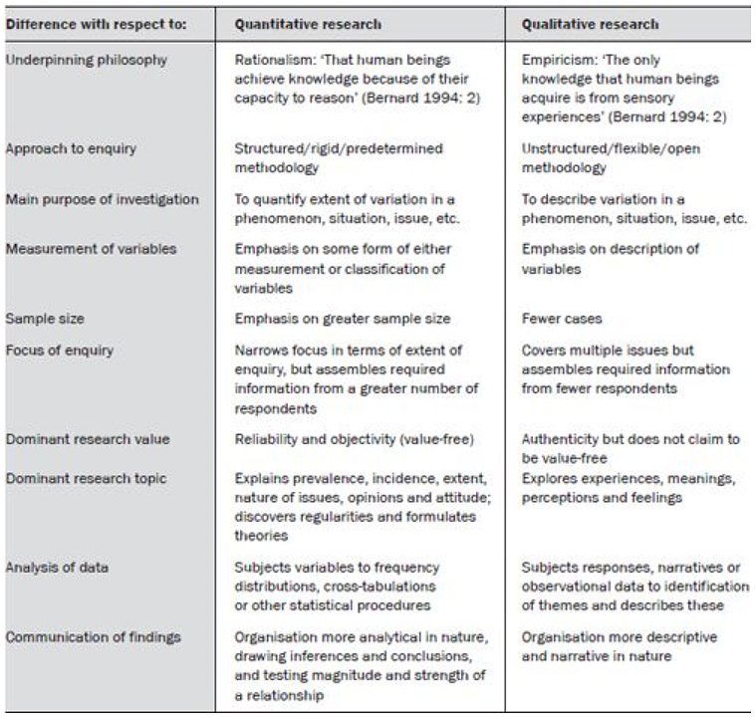

The Research Process and The Research Journey (Research Operational Steps) – touch each post and select methods and procedures appropriate for your journey
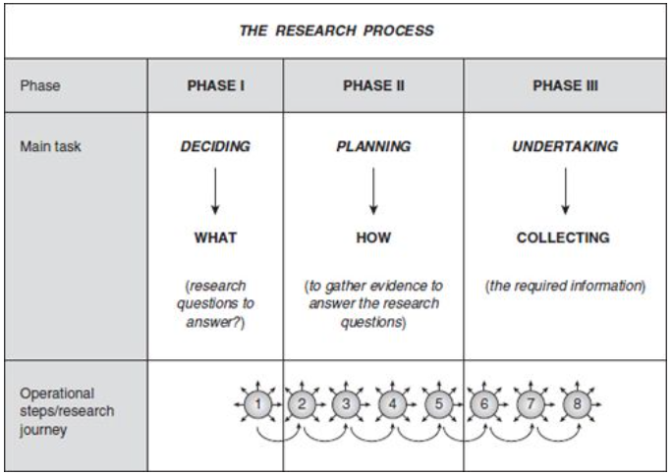

Sumber:
- Ranjit Kumar, “RESEARCH METHODOLOGY: a step-by-step guide for beginners”, Sage, 2011

