Complete EPC Diagram Guide
EPC diagram guide or tutorial helps you better understand EPC diagram so that you can make full use of it for good purpose.
EPC diagram uses EPC diagram symbols to show the control-flow structure of a business process as a chain of events and functions. EPC diagram can be used for resource planning and identifying possible improvements of a business process.

The Definition of EPC Diagram
EPC diagram, short for event-driven process chain diagram, is a type of flowchart used for business process modeling. EPC was invented back in 1992 by Prof. Scheer and colleagues at the University of Saarland. Since then, they have seen an industry wide adoption. EPC diagram can be used to describe business processes and workflows.
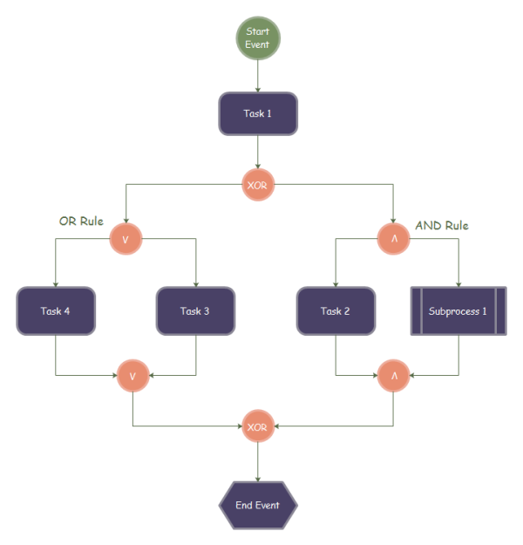

EPC Diagram Rules & Symbols
Knowing EPC diagram rules and symbols are quite important when drawing EPC diagrams. The beginning and the end of every event-driven process chain is always illustrated by an EPC event. An EPC event is defined by the conditions that must be met to start and end the process. Multiple functions can follow each event or multiple events can follow each function, but there must be rules in between. In an EPC, such rules are called 'OR', 'AND', or 'XOR' and are represented as graphical connectors, just as the picture above shows.
Now let us learn some basic knowledge about EPC diagram symbols. An event describes what circumstances a function or a process works or which state a function or process results in.
The beginning and the end of every event-driven process chain is always illustrated by an EPC event. An event is defined by the conditions that must be met to start and end the process.
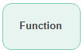
A function describes the transformations from an initial state to a resulting state.
An AND operation corresponds to activating all paths in the control flow concurrently.
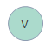
An OR operator corresponds to activating one or more paths among control flows.
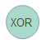
An XOR operator corresponds to making decision of which path to choose among several control flows.
An information resource portrays objects in the real world that can be input data serving as the basic of a function, or output data produced by a function.

EPC Diagram Symbols
Pre-drawn EPC Diagram symbols represent event, function, process path, XOR, OR, AND, etc. These symbols help create accurate diagrams and documentation.
EPC diagram templates include many special shapes, event, function, process path, XOR, OR, AND, joint, organizational unit, informational or material, information box, main process, component, etc. These shapes enable you to draw a professional-looking EPC diagrams.
Complete EPC Diagram Guide

EPC Diagram Symbols
EPC Diagram Shapes
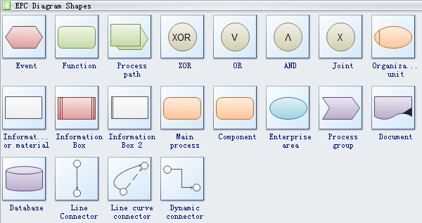
Event describes the circumstance and state a function or a process works or results in. Generally, an EPC diagram must start with an event and end with an event.
Function displays the transformations from an initial state to a resulting state
Process path is the series of states that a system passes through as it moves from an initial state to a final state.
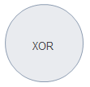
XOR is a logical operation, pronounced exclusive or. It can be used to cipher messages simply and fast.
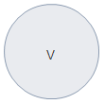
OR corresponds to activating one or more paths among control flows.
Opening AND represents a fork and closed AND represents a joint.
Organization unit describes the specific duty of a person or an organization.
Main process is an important part in the whole process.
Information box is used for identification, reference, and scale information.
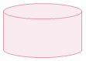
Database is a structured set of data held in a computer, especially one that is accessible in various ways.

Steps to Draw an EPC Diagram
Although it is quite convenient to use EPC diagram to visually display the business process, however, drawing EPC diagram by hand is kind of difficult. No worries, you can quickly and correctly draw an EPC diagram with the help ofEPC diagram maker. Now, let me show you how to do it step by step.
First things first, on the "File" menu, point to "New", point to "Business Diagram", and then click "EPC".
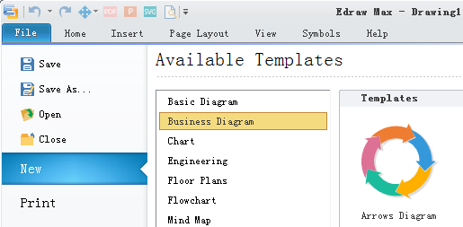
Drag and drop symbols you need from "EPC Diagram Shapes" in the library which is on the left of the canvas.
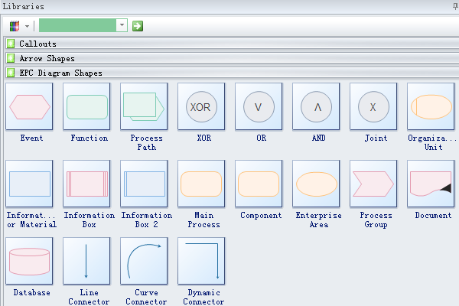
Use line connectors, curve connectors or dynamic connector to connect the EPC symbols you have chosen.
To add text to a shape, select it, and then type. When you finish typing, click outside the text block.
To align multiple shapes vertically or horizontally, select the shapes you want to align, and then on the "Home menu", click "Align".
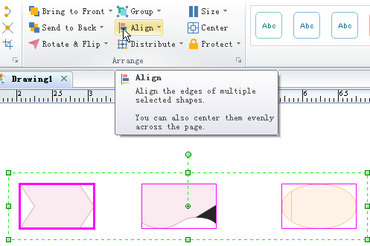
You can modify other EPC diagram features to make it look more attractive

